**CHAPTER 2**

**1.Declare several variables** by selecting for each one of them the most appropriate of the types **sbyte**, **byte**, **short**, **ushort**, **int**, **uint**, **long** and **ulong** in order to assign them the following values: 52,130; -115; 4825932; 97; -10000; 20000; 224; 970,700,000; 112; -44; -1,000,000; 1990; 123456789123456789.

using System;

namespace detyra1

{

class Program

{

static void Main(string[] args)

{

ushort number1 = 52130;

sbyte number2 = -115;

int number3 = 4825932;

byte number4 = 97;

short number5 = -10000;

ushort number6 = 20000;

byte number7 = 224;

uint number8 = 970700000;

byte number9 = 112;

sbyte number10 = -44;

int number11 = -1000000;

ushort number12 = 1990;

ulong number13 = 123456789123456789;

Console.WriteLine(number1, number2, number3, number4, number5, number6, number7, number8, number9, number10, number11, number12, number13);

Console.ReadKey();

}

}

}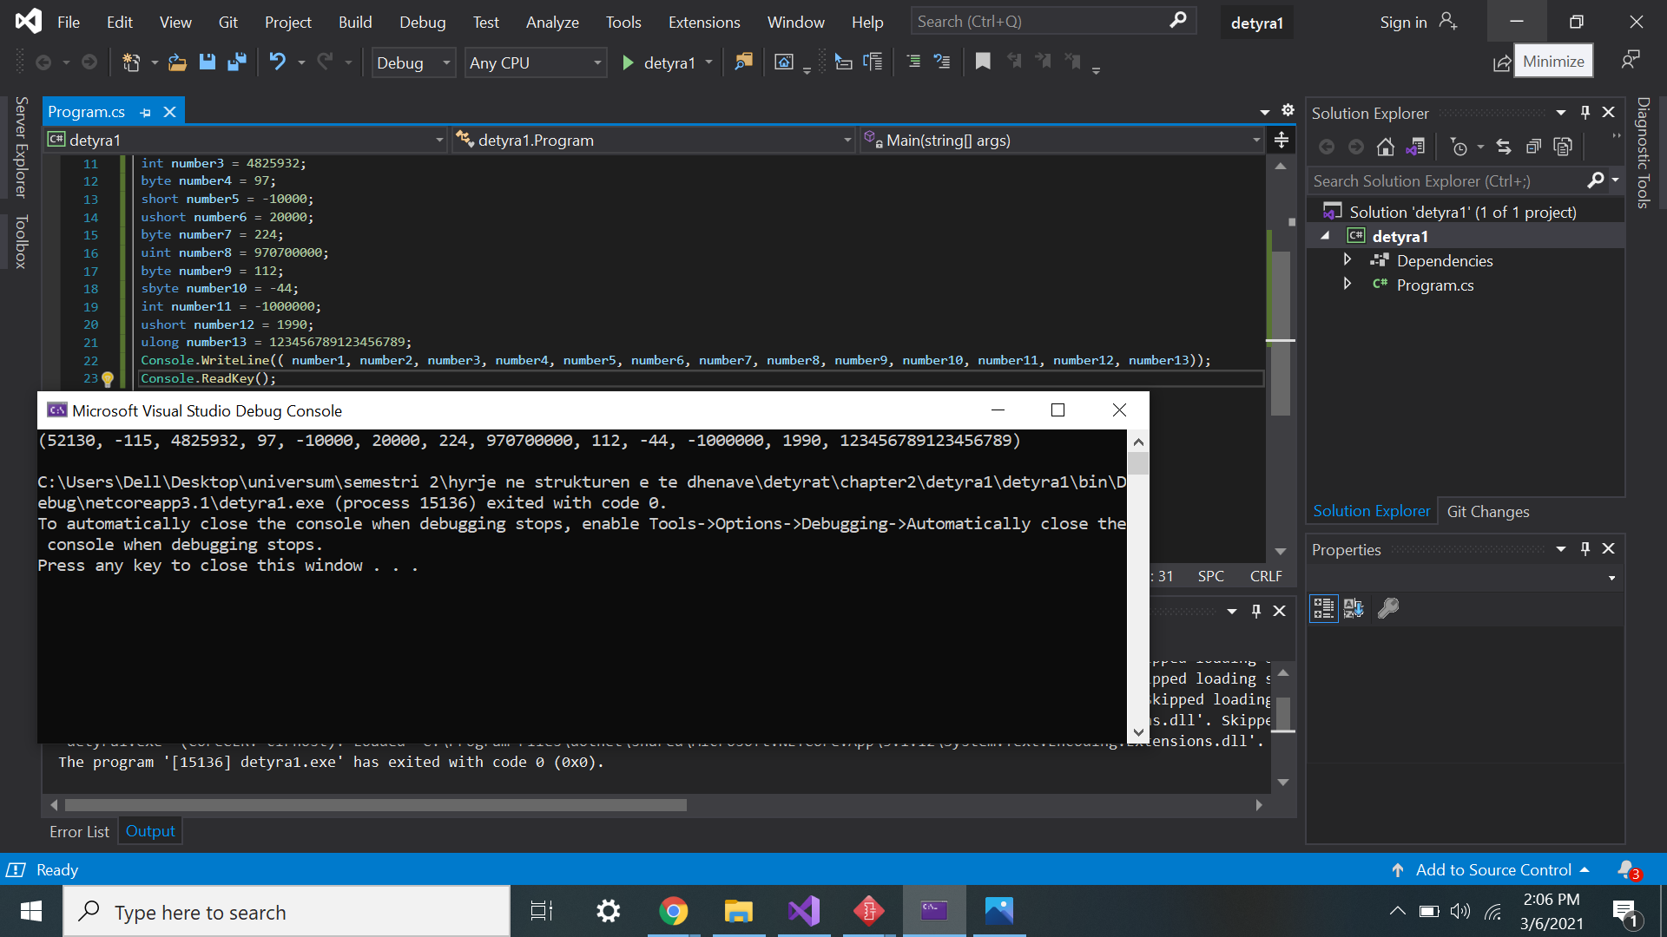

2.Which of the following values can be assigned to variables of type **float**, **double** and **decimal**: 5, -5.01, 34.567839023; 12.345; 8923.1234857; 3456.091124875956542151256683467?

1. using System;
2. namespace Java2
3. {
4. class Program
5. {
6. static void Main(string[] args)
7. {
8. decimal numri1 = 3456.091124875956542151256683467M;
9. float numri2 = 5f;
10. float numri3 = -5.01f;
11. double numri4 = 34.567839023;
12. double numri5 = 8923.1234857;
13. float numri6 = 12.345f;
14. Console.WriteLine($"{numri1}\n{numri2}\n{numri3}\n{numri4}\n{numri5}\n{numri6}\n", numri1, numri2, numri3, numri4, numri5, numri6);
15. Console.ReadKey();
16. }
17. }
18. }

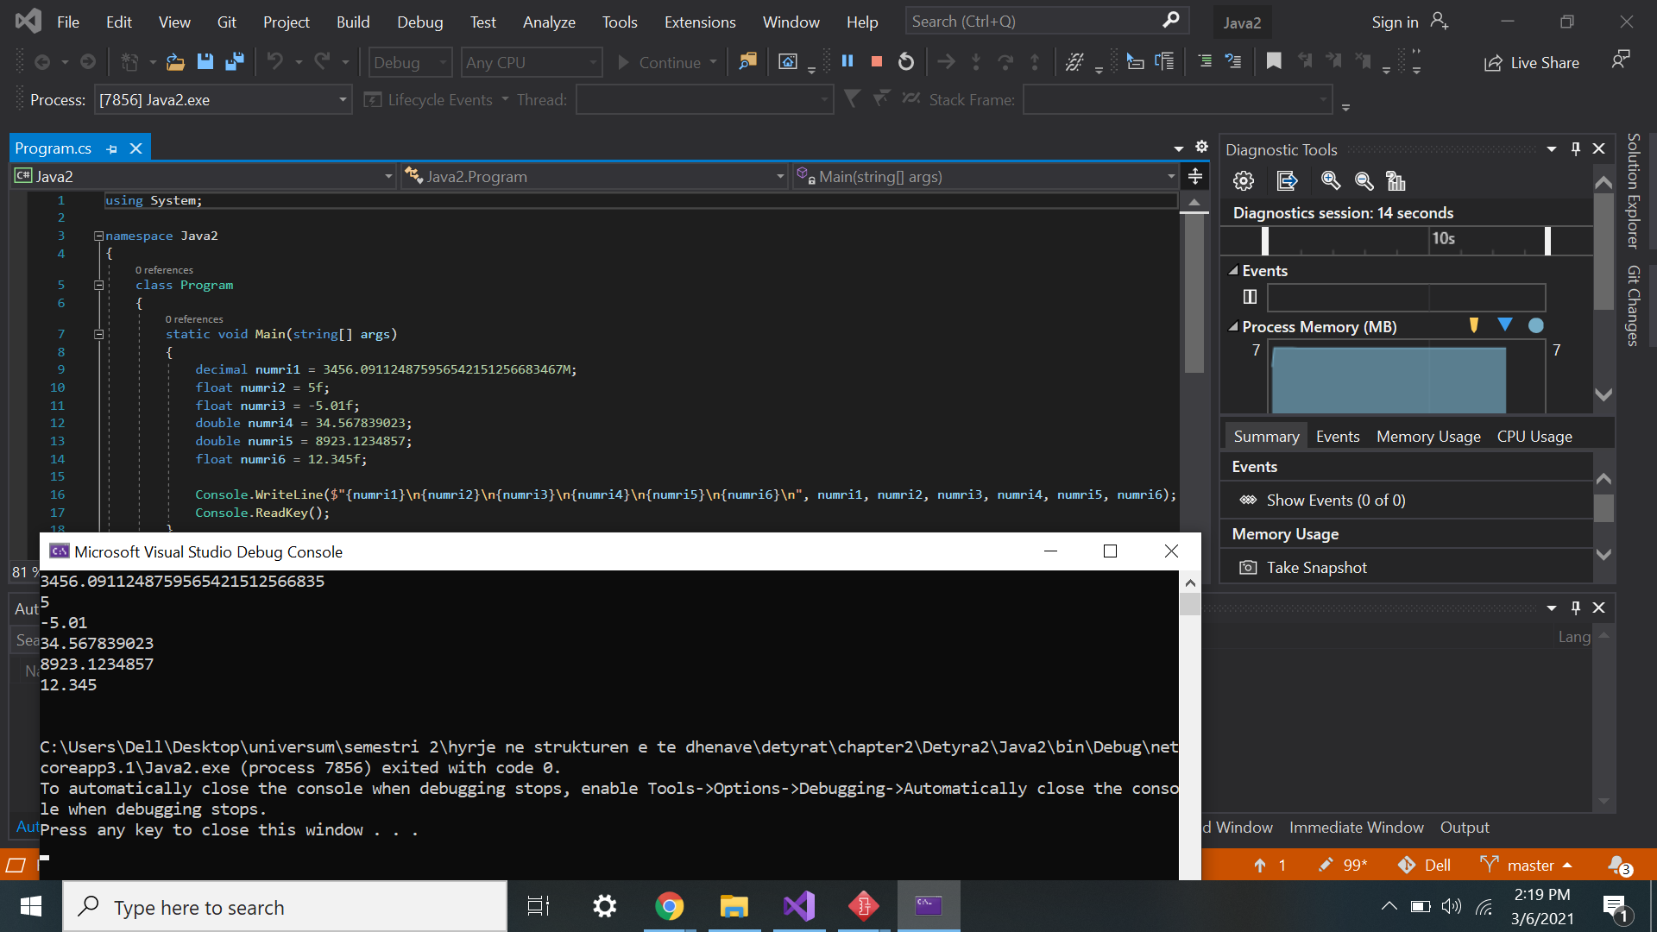

3.    Write a program, which **compares correctly** **two real numbers** with accuracy at least **0.000001**.

using System;

namespace detyra3

{

class Program

{

static void Main(string[] args)

{

decimal numri1 = 10.000001m;

decimal numri2 = 10.000001m;

Console.WriteLine(numri1.Equals(numri2));

}

}

}

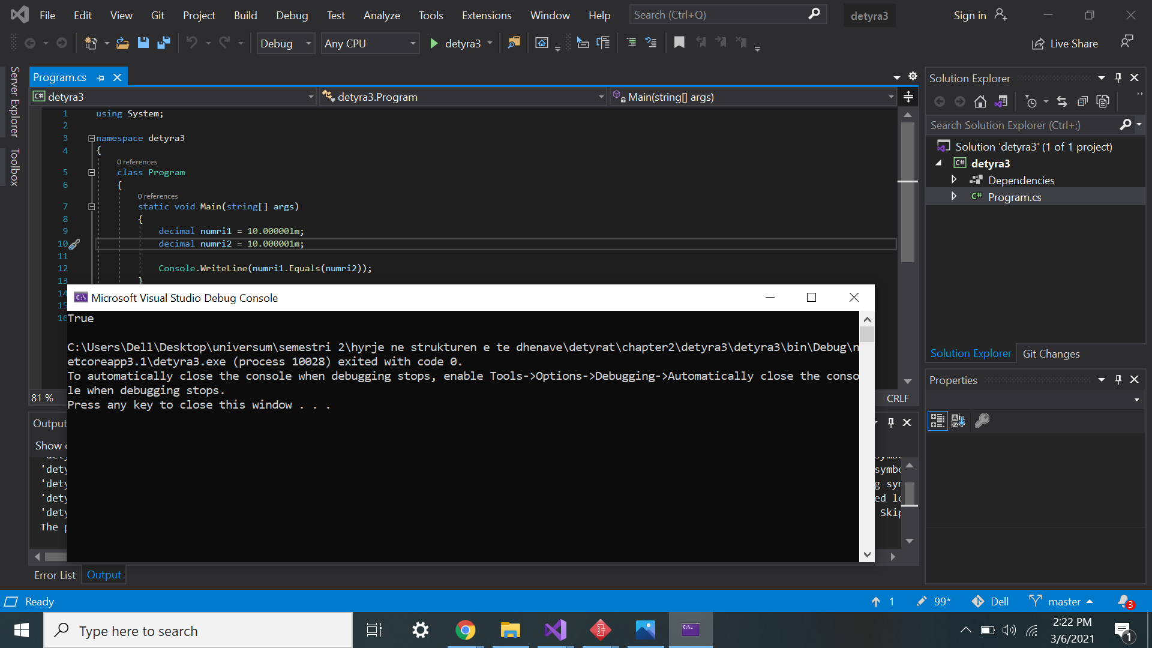

4.    **Initialize** a variable of type **int** with a value of 256 in  
**hexadecimal** format (256 is 100 in a numeral system with base 16).

using System;

namespace detyra4

{

class Program

{

static void Main(string[] args)

{

int hexNumber = 0x100;

Console.WriteLine(hexNumber);

Console.ReadKey();

}

}

}

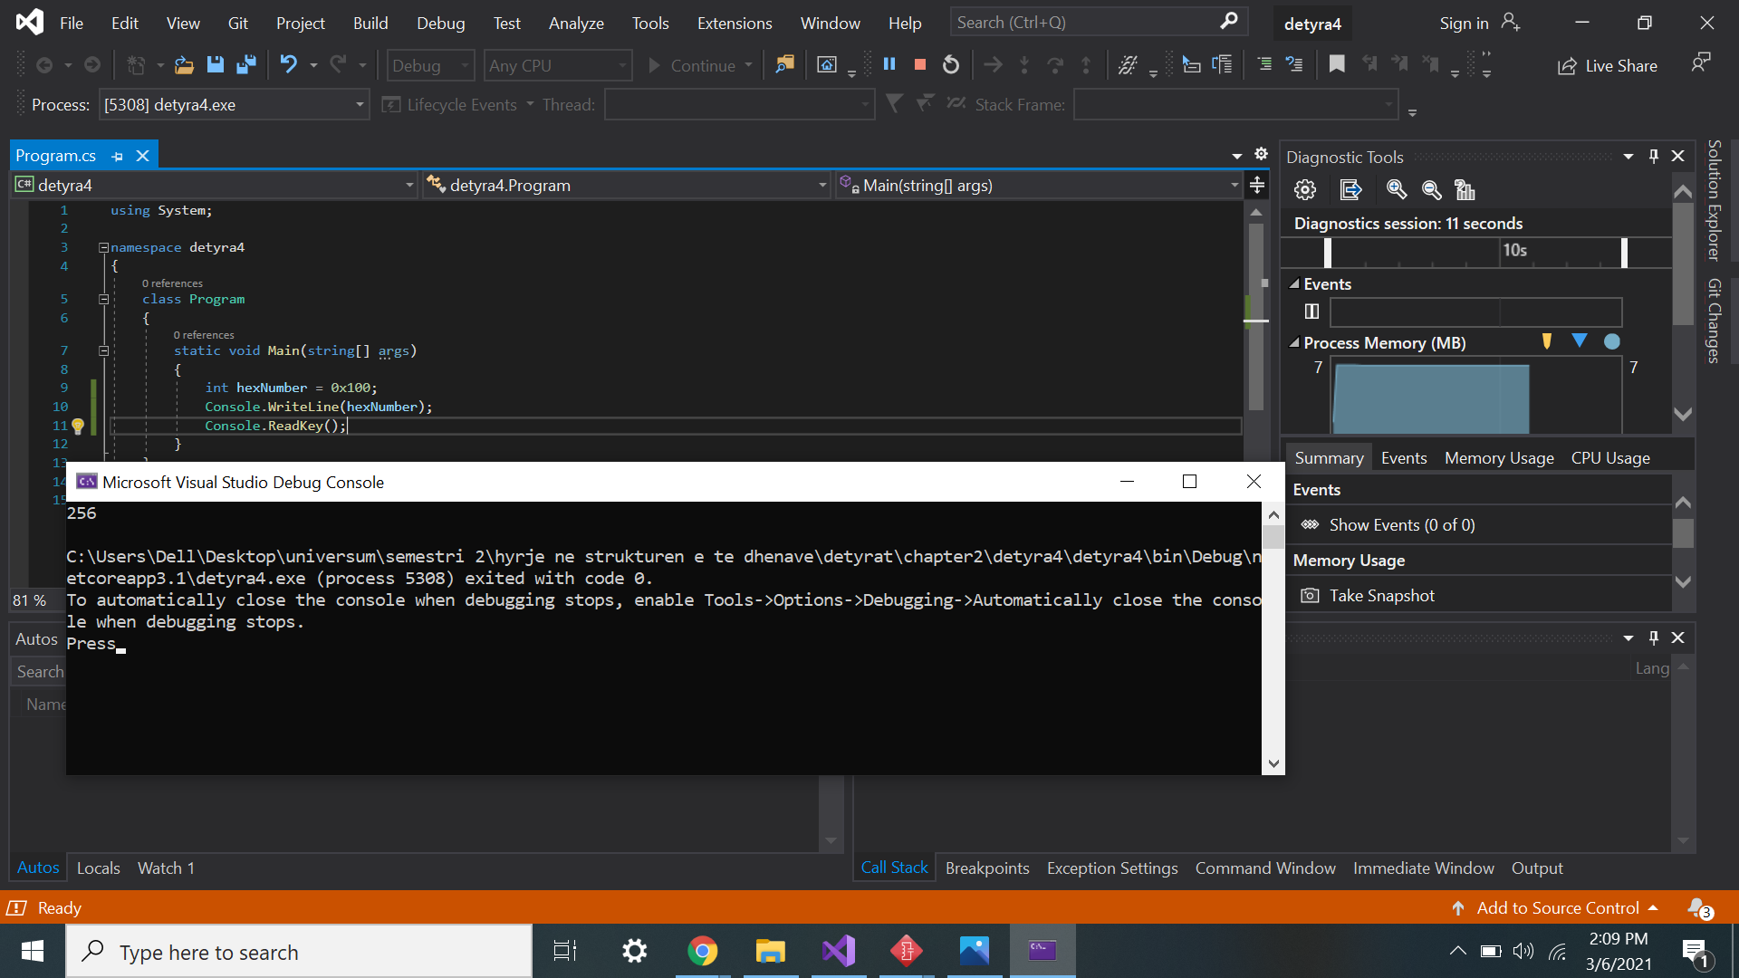

5.    Declare a variable of type **char** and assign as a value the character, which has **Unicode** code, 72 (use the Windows calculator in order to find hexadecimal representation of 72).

using System;

namespace Detyra5

{

class Program

{

static void Main(string[] args)

{

char diqka = '\u0072';

Console.WriteLine(diqka);

}

}

}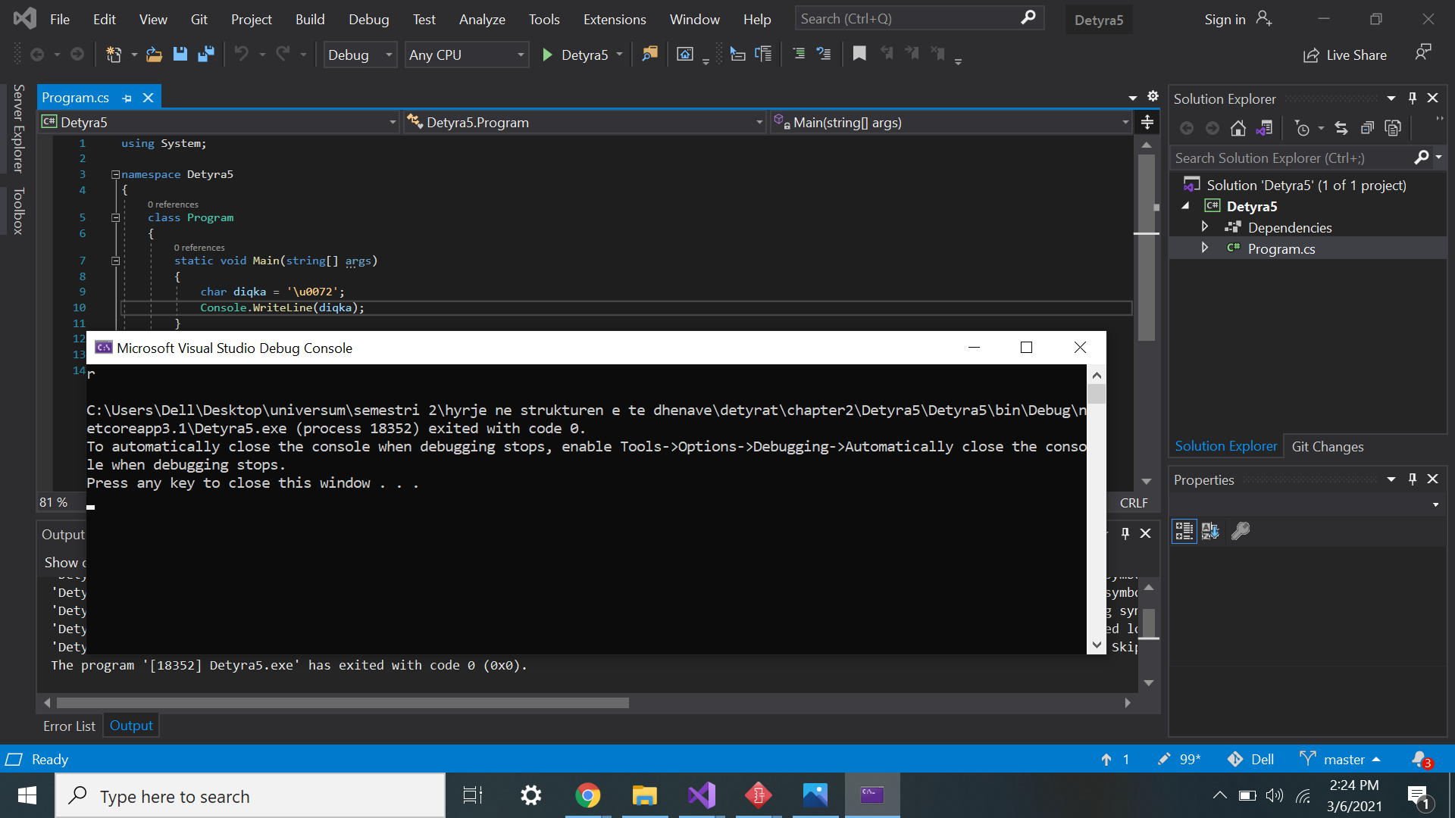

6.    Declare a variable **isMale** of type **bool**and assign a value to it depending on your gender.

using System;

namespace detyra6

{

class Program

{

static void Main(string[] args)

{

bool isMale = true;

Console.WriteLine(isMale);

}

}

}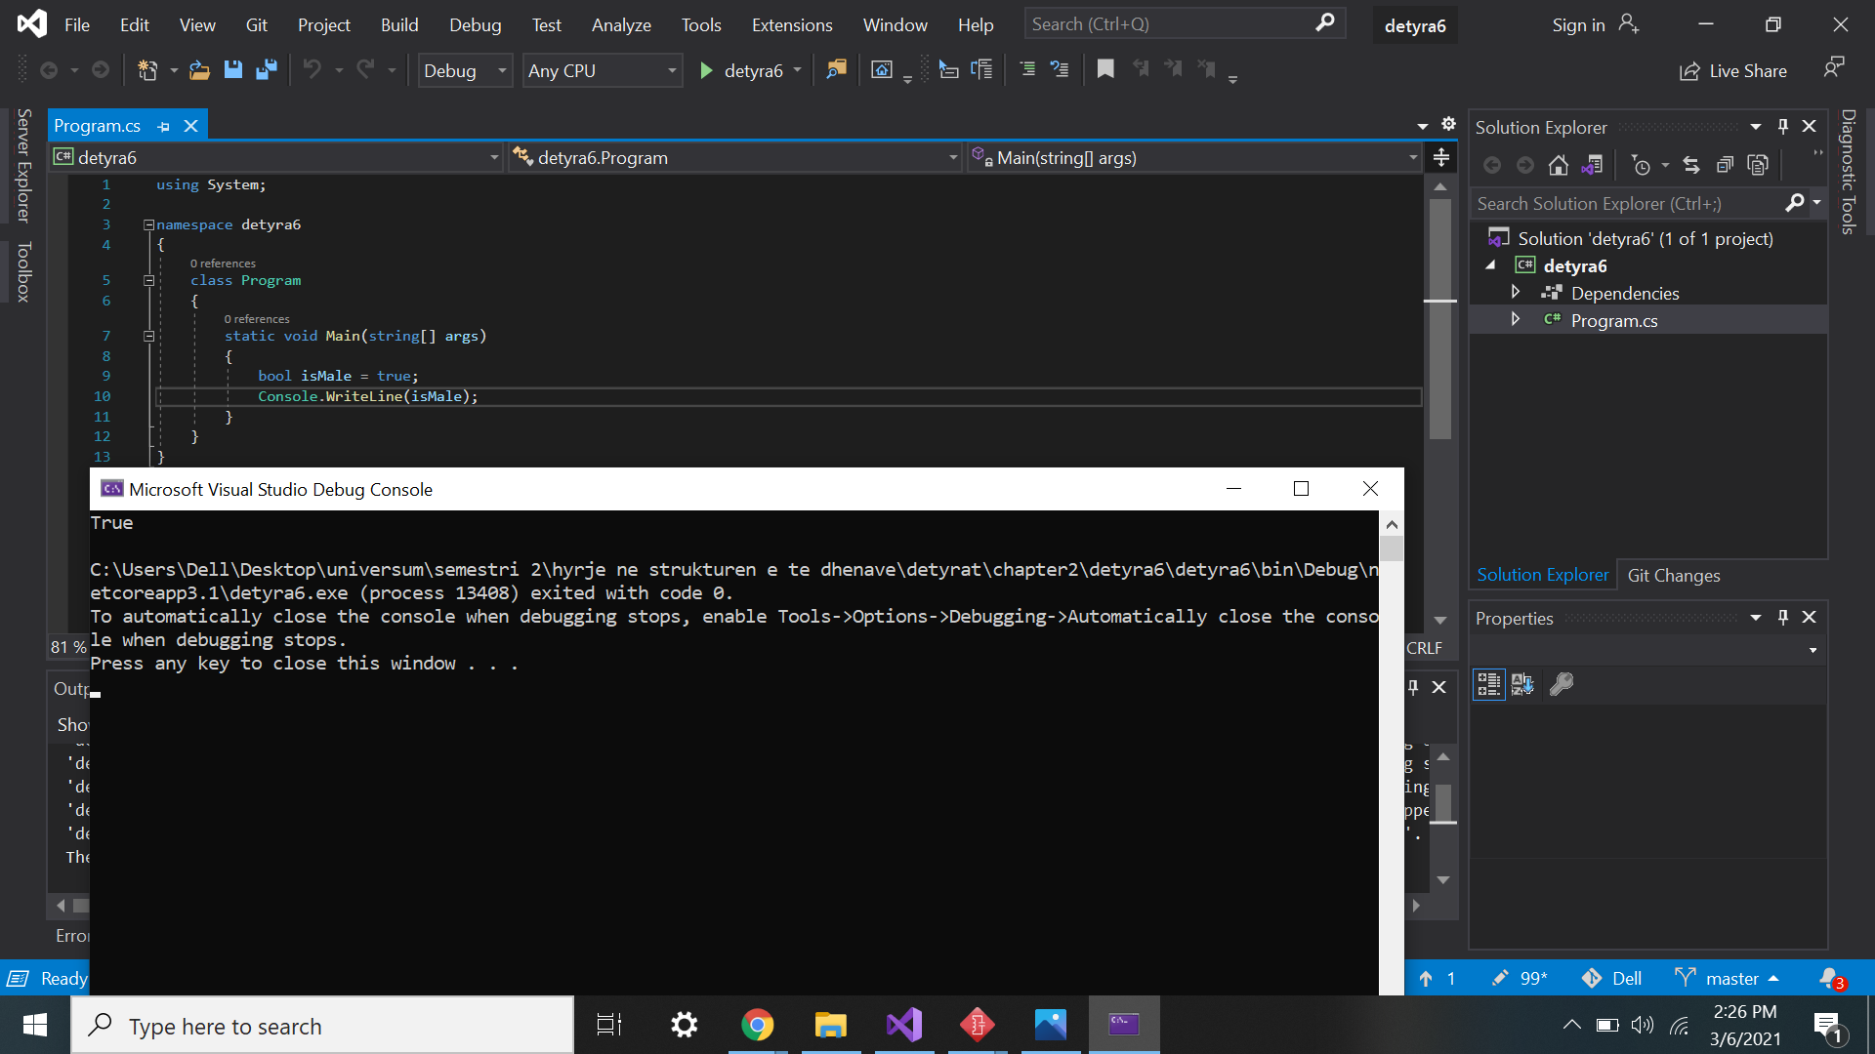

7.    Declare two variables of type **string** with values "Hello" and "World". Declare a variable of type **object**. Assign to this variable the value obtained of concatenation of the two string variables (add space if necessary). Print the variable of type **object**.

using System;

namespace Detyra7

{

class Program

{

static void Main(string[] args)

{

string str1 = "Hello";

string str2 = "World";

object obj = str1 + " " + str2;

Console.WriteLine(obj);

}

}

}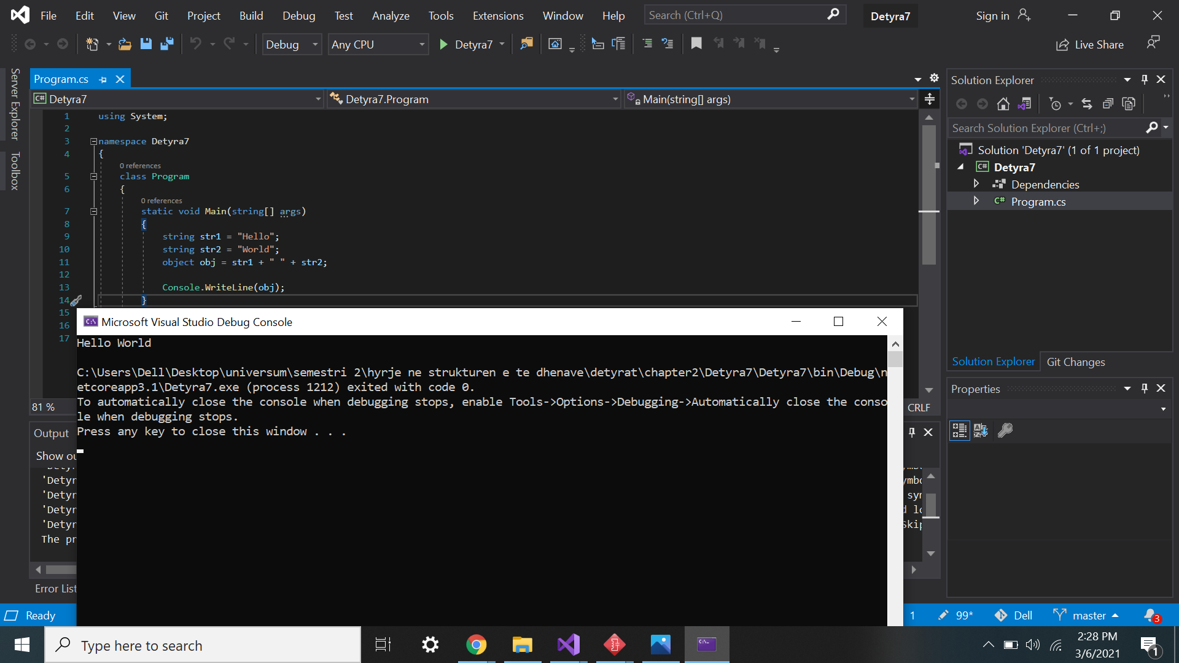

8.    Declare two variables of type **string** and assign them values "Hello" and "World". Declare a variable of type **object** and assign to it the value obtained of concatenation of the two variables of type **string** (do not miss the space in the middle). Declare a third variable of type **string** and initialize it with the value of the variable of type **object** (you should use type casting).

using System;

namespace detyra8

{

class Program

{

static void Main(string[] args)

{

string str1 = "Hello";

string str2 = "World";

object obj = str1 + " " + str2;

string str3 = obj.ToString();

Console.WriteLine("{0} {1} \n {2}", str1, str2, obj);

}

}

}

9.    Declare two variables of type **string** and assign them a value “**The "use" of quotations causes difficulties.**” (without the outer quotes). In one of the variables use quoted string and in the other do not use it.

using System;

namespace detyra9

{

class Program

{

static void Main(string[] args)

{

string noQuotes = "The use of quotations cause difficulties.";

string quotes = "The \"use\" of quotationscauses difficulties.";

Console.WriteLine(noQuotes);

Console.WriteLine(quotes);

}

}

}

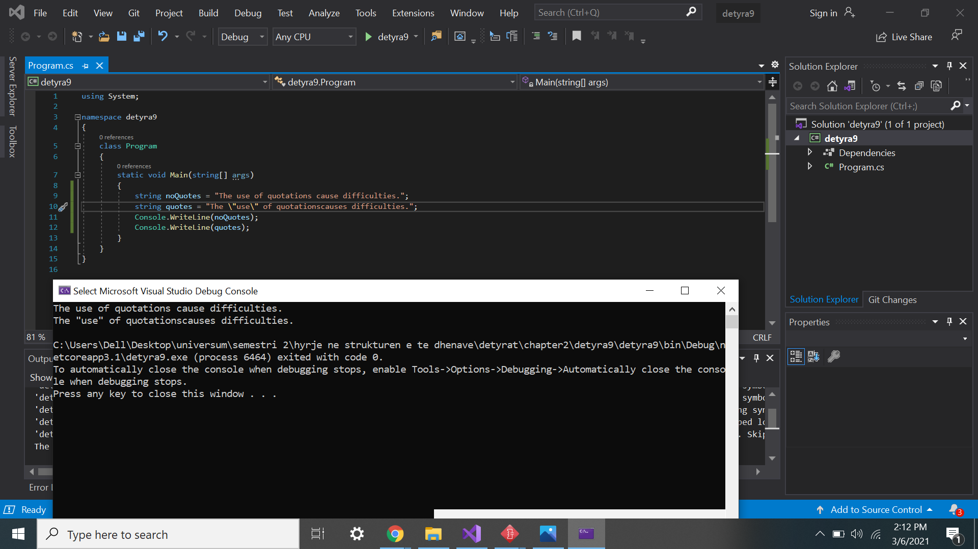

10.   Write a program to print a figure in the shape of a **heart** by the sign "**o**".

using System;

namespace Detyra10

{

class Program

{

static void Main(string[] args)

{

Console.WriteLine(" 0 0 ");

Console.WriteLine("0 0 0 0");

Console.WriteLine(" 0 0 0 0");

Console.WriteLine(" 0 00 0");

Console.WriteLine(" 0 0 ");

Console.WriteLine(" 0 0 ");

Console.WriteLine(" 0 0 ");

Console.WriteLine(" 00 ");

Console.ReadKey();

}

}

}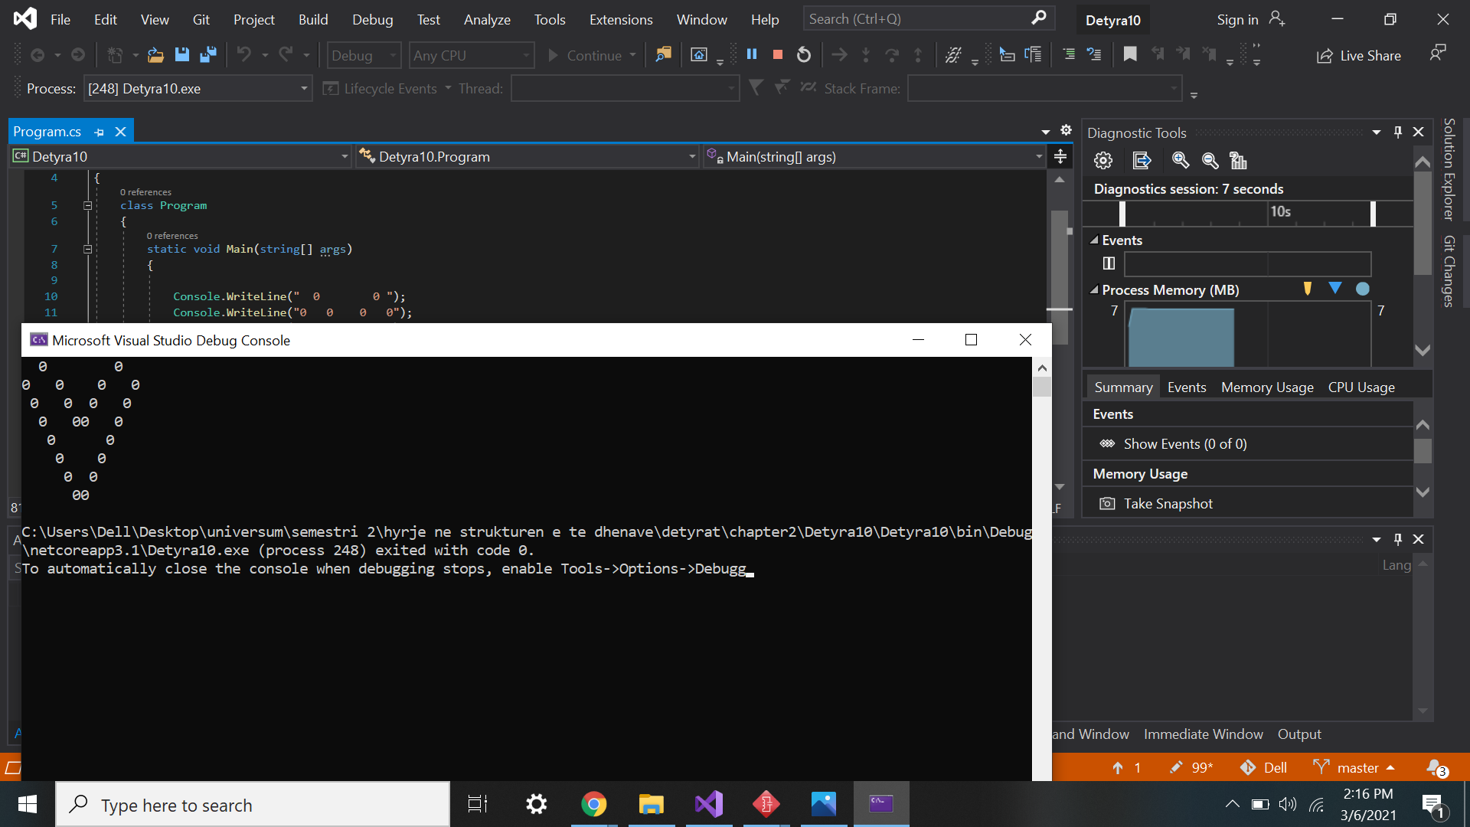

11.   Write a program that prints on the console **isosceles triangle** which sides consist of the copyright character "**©**".

12.   A company dealing with marketing wants to keep a data record of its **employees**. Each record should have the following characteristic – first name, last name, age, gender (‘m’ or ‘f’) and unique employee number (27560000 to 27569999). **Declare appropriate variables** needed to maintain the information for an employee by using the appropriate data types and attribute names.

using System;

namespace detyra12

{

class Program

{

static void Main(string[] args)

{

string firstName = "Mehreme";

string lastName = "Gashi";

byte age = 18;

char gender = 'f';

uint id = 62727218;

Console.WriteLine(firstName);

Console.WriteLine(lastName);

Console.WriteLine(age);

Console.WriteLine(gender);

Console.WriteLine(id);

}

}

}

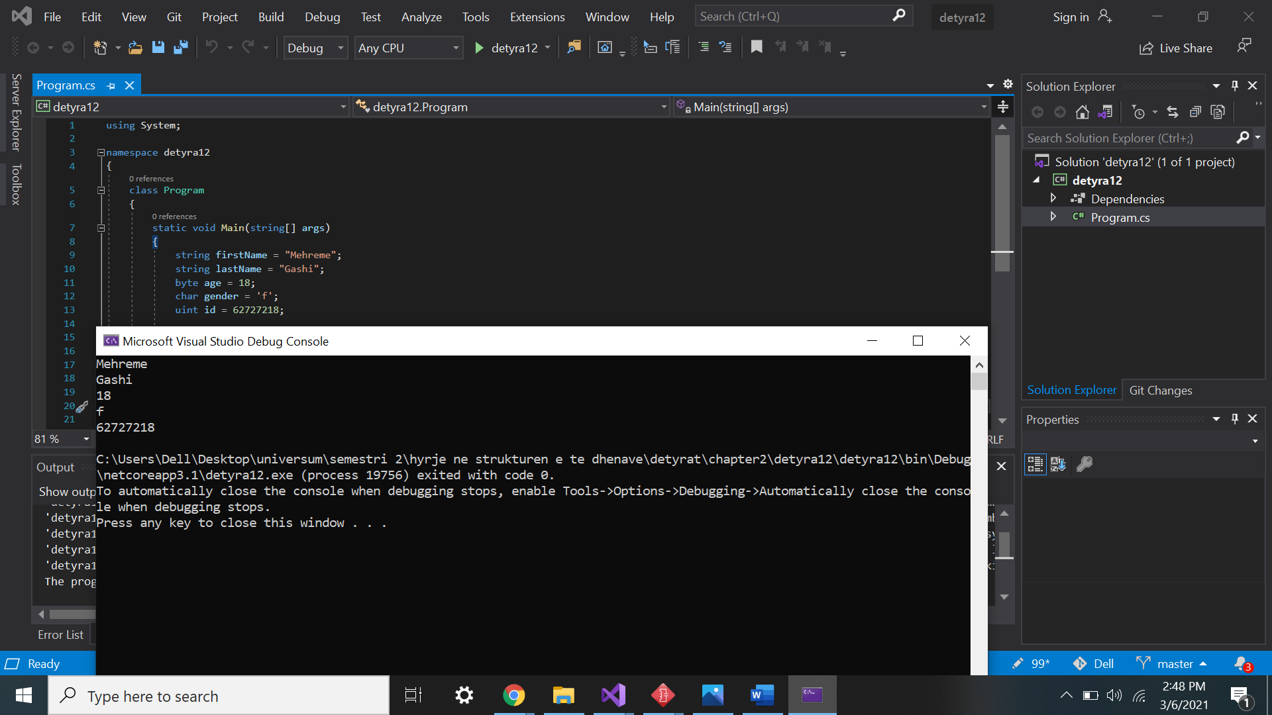

13.   Declare two variables of type **int**. Assign to them values 5 and 10 respectively. **Exchange (swap) their values** and print them.

using System;

namespace detyra13

{

class Program

{

static void Main(string[] args)

{

int number1 = 5;

int number2 = 10;

int placeholder = number2;

number2 = number1;

number1 = placeholder;

Console.WriteLine(number1);

Console.WriteLine(number2);

}

}

}

